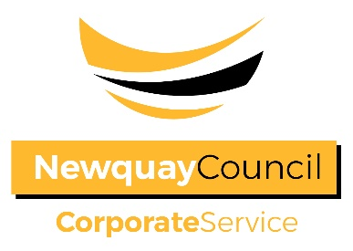
Newquay Town Council

NOTICE OF CONCLUSION OF AUDIT

ANNUAL GOVERNANCE AND ACCOUNTABILITY RETURN
FOR THE YEAR ENDED 31 MARCH 2019

Sections 20(2) and 25 of the Local Audit and Accountability Act 2014

Accounts and Audit Regulations 2015 (SI 2015/234)

Accounts and Audit (Coronavirus) (Amendment) Regulations 2020 (SI 2020/404)

- The audit of accounts for Newquay Town Council for the year ended 31 March 2020 has been completed and the accounts have been published.

- The Annual Governance & Accountability Return is available for inspection by any local government elector of the area of Newquay Town Council on application to:

  - Mr Andrew Curtis, Town Clerk & Responsible Financial Officer

  - Monday – Thursdays 09:30 – 16:30
Fridays 10:00 – 16:00

- Copies will be provided to any person on payment of £3 for each copy of the Annual Governance & Accountability Return.

Announcement made by: Mr Andrew Curtis, Town Clerk & RFO

Date of Announcement: Friday 16 August 2019

